 Auto – Buy & Sell

Chaitanya Vijay Parab, Kizhar Ahmed Katheem, Mohd Shoeb Shaikh, Amman Akhtar Sayed, Vishal Ratansing Patil

Researcher, Researcher, Researcher, Researcher, Guide

Computer Science of Engineering,

Rizvi College of Engineering, Mumbai, India

________________________________________________________________________________________________________

*Abstract :*  The main aim of this project is to predict a live increase in Stock using various strategies developed by us. This project is about creating stock, forex, and crypto marketing trading easier in any exchange at any timeframe you like from 1 minute to even investment and swing trading. We have used five base strategies and one advanced strategy for this project. The base strategies are Linear Regression, SAR, MACD, RSI and Super-Trend. And the advanced strategy used is a mixture of two base classes – SAR and Super Trend, called by us Super SAR. This indicator also Displays where you should put your trade and where to put stop loss and take a profit. It also contains a Back Tester which can help the user see whether the strategy is profitable in a particular chart and timeframe.

*IndexTerms* – Stock, Strategies, Indicators, Timeframe, Trading, Investment

*________________________________________________________________________________________________________*

# **Introduction**

Stock trading involves buying and selling shares in a certain company. If you own certain stocks and shares of a company, it translates to you owning a piece of the firm. A professional or an individual who trades on behalf of a financial firm will be known as a stock trader. An individual trader will buy and sell via a brokerage or an agent. On the other hand, institutional traders are mostly employed by investment companies. Stock traders provide liquidity to the markets and employ several methods and styles for defining their strategies. Stock trading has two main types - individual stock trading and institutional stock trading. Stock traders are different from stock investors. Stock traders trade equity securities, whereas stock investors utilize their own funds to purchase securities. The stock investor's primary goal is to produce interest income or to profit from the increase in value, also termed capital gains. We have used five base strategies and one advanced strategy for this project. The base strategies are Linear Regression, SAR, MACD, RSI and Super-Trend. And the advanced strategy used is a mixture of two base classes – SAR and Super Trend, called by us Super SAR. This indicator also Displays where you should put your trade and where to put stop loss and take a profit. It also contains a Back Tester which can help the user see whether the strategy is profitable in a particular chart and timeframe

**Data and Sources of Data**

We have found from the study of a research paper made by Bhaskar V. Patil, Rahul J. Jadhav that, now a day’s computers are a very essential part of our life. In today’s world of extreme competition on the business front, information exchange and efficient communication is the need of the day. The internet is the highway that connects you to millions of computers together globally, forming networks in which any computer can communicate with any other computer as long as they are both connected to the internet. This fantastic world of computers and their worldwide network has been replete with incidences of malicious attacks of a virus created by people who get the thrills of spotting loopholes and making an entry into other computer systems. 'Virus' is a generic term for software that is harmful to your system. They spread via disks, a network, or via services such as email. Irrespective of how the virus travels, its purpose is to use or damage the resources of your computer. The history of the worst computer virus attacks dates back to 1998 and since then the world of computers has witnessed several computer attacks which were shocking in their times. Now (from 2010 onwards) computer attacks are not shocking anymore, the world of computers has learned to take into its stride computer attacks and has also learned to deal with malware. Viruses are classified as Compiled viruses, Boot Sector viruses, Interpreted viruses, Multi-partite Viruses, and Radio Frequency Identification [RFID] viruses. There are different computer viruses and their variants that are created and find their way into other computers through networks and media. But there is some mechanism to find particular viruses and their categories.

**Theoretical framework**

A computer virus is a type of computer program that, when executed, replicates itself by modifying other computer programs and inserting its own code. If this replication succeeds, the affected areas are then said to be "infected" with a computer virus, a metaphor derived from biological viruses.

Computer viruses generally require a host program. The virus writes its code into the host program. When the program runs, the written virus program is executed first, causing infection and damage. A computer worm does not need a host program, as it is an independent program or code chunk. Therefore, it is not restricted by the host program but can run independently and actively carry out attacks.

Virus writers use social engineering deceptions and exploit detailed knowledge of security vulnerabilities to initially infect systems and spread the virus. The vast majority of viruses target systems running Microsoft Windows, employing a variety of mechanisms to infect new hosts, and often using complex anti-detection/stealth strategies to evade antivirus software. Motives for creating viruses can include seeking profit (e.g., with ransomware), desire to send a political message, personal amusement, to demonstrate that a vulnerability exists in software, sabotage and denial of service, or simply because they wish to explore cybersecurity issues, artificial life and evolutionary algorithms.

Computer viruses cause billions of dollars’ worth of economic damage each year.

In response, an industry of antivirus software has cropped up, selling or freely distributing virus protection to users of various operating systems.

**RESEARCH METHODOLOGY**

**Data and Sources of Data**

We have found from the study of a research paper made by Muchelule Yusuf Wanjala & Neyole Misiko Jacob that, With the Internet as a major essential communication between billions of people and also a tool for commerce, social interaction, there are increasingly new threats in viruses as new unrecognized signatures are evolving for the antiviruses to detect during the scan. Anti-virus software uses a virus signature to find a virus in a computer file system, allowing to detect, quarantine and remove the virus. In the anti-virus software, the virus signature is referred to as a definition file or DAT file. Anti-virus software performs frequent virus signature, or definition, updates. These updates are necessary for the software to detect and remove new viruses. New viruses are being created and released almost daily, which forces anti-virus software to need frequent updates. The ability to detect heuristically or generically is significant, given that most scanners now include more than 250k signatures and the number of new viruses being discovered continues to increase dramatically year after year. Further, Landesman indicates that to maintain the highest level of protection, configure your antivirus software to check for updates as often as it will allow. Keeping the signatures up to date doesn't guarantee a new virus will never slip through, but it does make it far less likely.

**Theoretical framework**

A computer virus is a type of computer program that, when executed, replicates itself by modifying other computer programs and inserting its own code. If this replication succeeds, the affected areas are then said to be "infected" with a computer virus, a metaphor derived from biological viruses.

Computer viruses generally require a host program. The virus writes its code into the host program. When the program runs, the written virus program is executed first, causing infection and damage. A computer worm does not need a host program, as it is an independent program or code chunk. Therefore, it is not restricted by the host program but can run independently and actively carry out attacks.

Virus writers use social engineering deceptions and exploit detailed knowledge of security vulnerabilities to initially infect systems and spread the virus. The vast majority of viruses target systems running Microsoft Windows, employing a variety of mechanisms to infect new hosts, and often using complex anti-detection/stealth strategies to evade antivirus software. Motives for creating viruses can include seeking profit (e.g., with ransomware), desire to send a political message, personal amusement, to demonstrate that a vulnerability exists in software, sabotage and denial of service, or simply because they wish to explore cybersecurity issues, artificial life and evolutionary algorithms.

Computer viruses cause billions of dollars’ worth of economic damage each year.

In response, an industry of antivirus software has cropped up, selling or freely distributing virus protection to users of various operating systems.

Antivirus software, or antivirus software (abbreviated to AV software), also known as anti-malware, is a computer program used to prevent, detect, and remove malware.

Antivirus software was originally developed to detect and remove computer viruses, hence the name. However, with the proliferation of other malware, antivirus software started to protect from other computer threats. In particular, modern antivirus software can protect users from malicious browser helper objects (BHOs), browser hijackers, ransomware, keyloggers, backdoors, rootkits, trojan horses, and worms, malicious LSPs, dialers, fraud tools, adware, and spyware. Some products also include protection from other computer threats, such as infected and malicious URLs, spam, scam and phishing attacks, online identity (privacy), online banking attacks, social engineering techniques, advanced persistent threats (APT), and botnet DDoS attacks.

**Descriptive Statistics**

Key Malware Statistics

* 560,000 new pieces of malware are detected every day.
* There are now more than 1 billion malware programs out there.
* Every minute, four companies fall victim to ransomware attacks.
* Trojans account for 58% of all computer malware.

No lesson in the history of malware is complete without mentioning ILOVEYOU. This worm is considered the most destructive computer virus of all time. It did one very simple thing: It renamed all files “iloveyou” until the system crashed. While the exact scope of this attack was never revealed, analysts said it affected roughly 10% of all PCs around the world. The infamous ILOVEYOU virus caused $10 billion of damage when it struck in 2009.

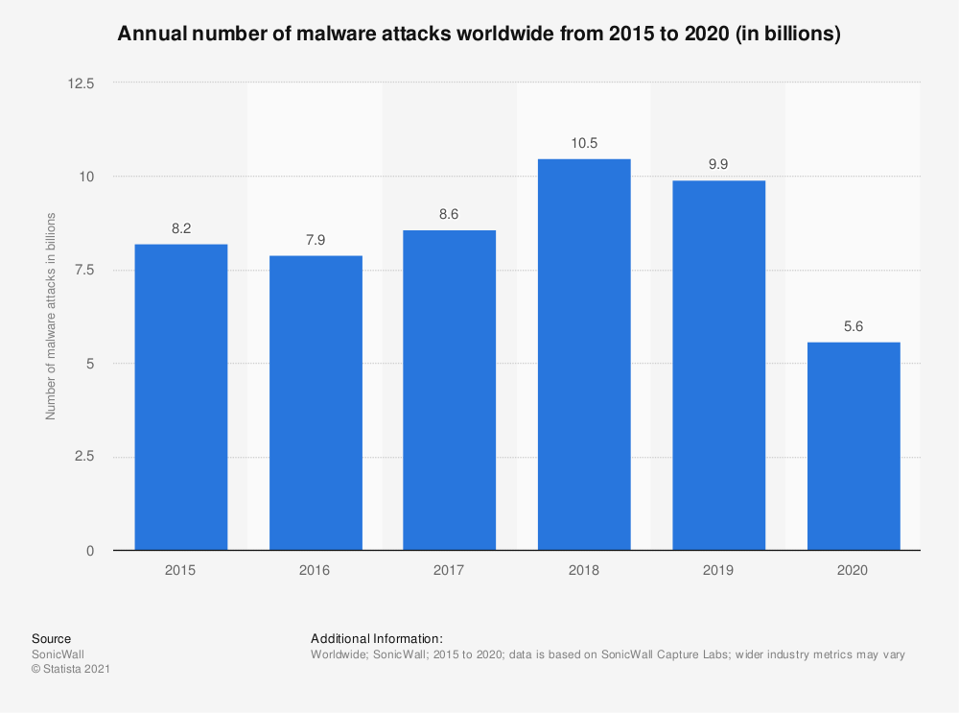

The cybersecurity market has grown rapidly over the last few years. Annual revenues for security software across the globe reached an estimated $40 billion in 2020, with that number expected to reach $42 billion in 2021.

Cybersecurity software makes up a large percentage of total information security spending. Norton and McAfee, for example, generated $2.49 billion and $2.635 billion of revenue respectively in 2020.

In terms of profit growth, however, most companies have plateaued in recent years, including names like Norton and Trend Micro. While IBM has shown a noticeable rise in profit in the past five years, the antivirus market is now taken up with free solutions like Microsoft Security Essentials, which collectively make up 30% of the market.

Many antivirus tests check for protection against:

* Zero-day attacks (viruses taking advantage of security holes before they are discovered and patched)
* Web and email threats
* Prevalent malware

Popular options like Bitdefender and Avira often combat as much as 100% against these attacks. Plus, most antivirus programs can run discreetly in the background without affecting the machine’s performance.

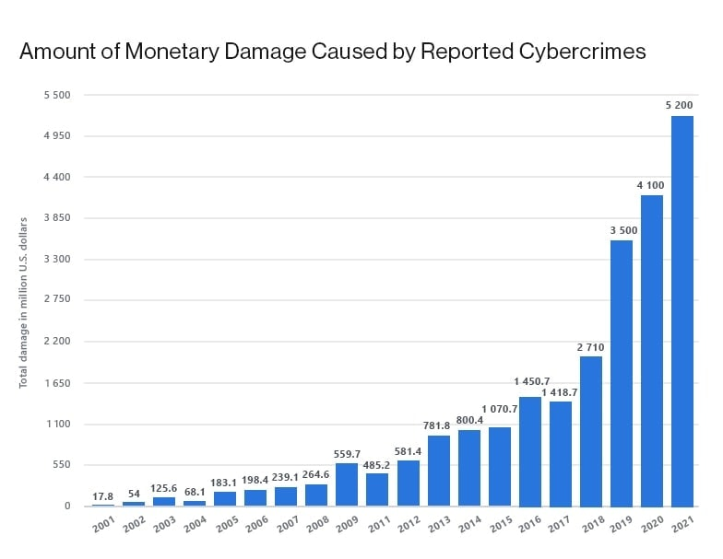

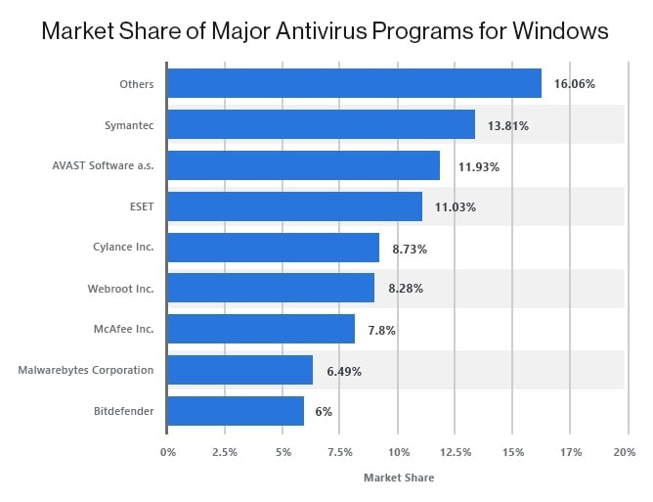

**II RESULTS AND DISCUSSION**

Stock analysis helps traders to gain an insight into the economy, stock market, or securities. It involves studying the past and present market data and creating a methodology to choose appropriate stocks for trading. Stock analysis also includes the identification of ways of entry into and exit from the investments. A stock is a form of security that indicates the holder has proportionate ownership in the issuing corporation and is sold predominantly on stock exchanges. Corporations issue stock to raise

funds to operate their businesses.

Advantages of Stock Recommendation System

• Removes the Investment Bias.

• Develops the Habit of Complete Analysis.

• Minimizes Your Losses.

• Assures Consistency.

• Gives a Better Idea about Entry and Exit Points.

• Allows the Smart Way of Making Money

# **III Acknowledgment**

I would like to express my deep gratitude to Professor Vishal Ratansing Patil., my research supervisor, for her patient guidance, enthusiastic encouragement and useful critiques of this research work.

I would also like to extend my thanks to the technicians of the laboratory of the Rizvi department for their help in offering me the resources in running the program.

Finally, I wish to thank my parents for their support and encouragement throughout my study.

# **References**

[1] J. Duan, H. Liu, and J. Zeng, “Posterior probability model for stock return prediction based on analyst’s recommendation behavior,” Knowledge-Based Systems, vol. 50, pp. 151–158, 2013.

[2] E. J. de Fortuny, T. de Smedt, D. Martens, and W. Daelemans, “Evaluating and understanding text-based stock price prediction models,” Information Processing & Management, vol. 50, no. 2, pp. 426–441, 2014.

[3] L. Huo, B. Jiang, T. Ning, and B. Yin, “A BP neural network predictor model for stock price,” in Intelligent Computing Methodologies, D. S. Huang, K. H. Jo, and L. Wang, Eds., Lecture Notes in Computer Science, pp. 362–368, Springer, Berlin,

Germany, 2014.

[4] A. A. Adebiyi, A. O. Adewumi, and C. K. Ayo, “Comparison of ARIMA and artificial neural networks models for stock price prediction,” Journal of Applied Mathematics, vol. 2014, Article ID 614342, 7 pages, 2014.

[5] K. Miwa and K. Ueda, “Slow price reactions to analysts’ recommendation revisions,” Quantitative Finance, vol. 14, no. pp.993–1004, 2014.

[6] Naadun Sirimevan; I.G. U. H. Mamalgaha; Chandira Jayasekara; Y. S. Mayuran; Chandimal Jayawardena (2020). Stock Market Prediction Using Machine Learning Techniques in Faculty of Computing, Sri Lanka Institute of Information Technology,

Malabe, Sri Lanka.

[7] Sukhman Singh; Tarun Kumar Madan; Jitendra Kumar; Ashutosh Kumar Singh (2020) Stock Market Forecasting using Machine Learning: Today and Tomorrow in National Institute of Technology, Kurukshetra, Haryana, India.

[8] Ferdiansyah Ferdiansyah; Siti Hajar Othman; Raja Zahilah Raja Md Radzi; Deris Stiawan; Yoppy Sazaki; Usman Ependi(2020). A LSTM-Method for Bitcoin Price Prediction: A Case Study Yahoo Finance Stock Market in School of Computing, Universiti Teknologi Malaysia, Johor Bahru, Johor, Malaysia.

[9] Meghna Misra; Ajay Prakash Yadav; Harkiran Kaur (2020). Stock Market Prediction using Machine Learning Algorithms: A Classification Study in Department of Computer Science and Engineering, (Deemed to be University, Patiala).

[10] Mojtaba Nabipour , Pooyan Nayyeri , Hamed Jabani , Shahab S., (Senior Member, Ieee), and Amir Mosavi (2020). Predicting Stock Market Trends Using Machine Learning and Deep Learning Algorithms Via Continuous and Binary Data; a Comparative Analysis.

[11] B Jeevan, E Naresh, B P Vijaya kumar, Prashanth Kambli (2019). Share Price Prediction using Machine Learning Technique in Department of Information Science and Engineering, RIT, Bangalore 560 054.

[12] Sumeet Sarode; Harsha G. Tolani; Prateek Kak; C S Lifna (2019). Stock Price Prediction Using Machine Learning Techniques in Vivekanand Education Society's Institute of Technology, Mumbai, India.

[13] Shao En Gao; Bo Sheng Lin; Chuin-Mu Wang(2019). Share Price Trend Prediction Using CRNN with LSTM Structure in Department of Computer Science and Information Engineering, National Chin-Yi University of Technology, Taichung, Taiwan. [14] Ishita Parmar; Navanshu Agarwal; Sheirsh Saxena; Ridam Arora; Shikhin Gupta; Himanshu Dhiman; Lokesh Chouhan (2019). Stock Market Prediction Using Machine Learning in Department of Computer Science and Engineering, National Institute Of Technology, Hamirpur, INDIA.

[15] A.J.P. Samarawickrama; T.G.I. Fernando(2018). A recurrent neural network approach in predicting daily stock prices an application to the Sri Lankan stock market in Department of Computer Science, Faculty of Applied Sciences University of Sri Jayewardenepura, Nugegoda, Sri Lanka.